Methods
This section provides an overview of the data and methods used to predict competitiveness in our base of 10 clean technologies.
A.1. Country Competitiveness Data
We measure competitiveness in 10 clean energy technologies through revealed comparative advantage, with trade data sourced from the United Nations ComTrade database and cleaned by the and cleaned by the Centre d'Études Prospectives et d'Informations Internationales (CEPII) statistics division Base pour l'Analyse du Commerce International (BACI). We include data for the years 2003-2023 in the analysis to avoid pervasive missingness in reporting prior to 2003 and utilize a set of Harmonized System (HS) codes that correspond most closely to our dependent variables (e.g. wind turbines were not an HS6 product in 1992). We further restrict our analysis to countries with a population of over 1 million people.
In each model, our primary dependent variable is a binary indicator taking the value of 1 if a country has a revealed comparative advantage (RCA) over 1, meaning that it exports more than its “fair share” of one of the clean technologies in our study.
Independent Variables
Our model uses three sets of independent variables as predictors, described across three separate subsections immediately below. Each of the 10 clean energy technologies that we consider utilizes a unique set of independent variables derived from products along the supply chain for a technology and products “proximate” to those along the supply chain.
Revealed Comparative Advantage in Product Data
The first set of independent variables are RCA in products and process equipment along the supply chain of each clean technology. We map the supply chains of each technology and assign each product and piece of process equipment with a 6-digit HS Code. Supplementary information Section Table SI.1 provides a detailed overview of the methodology utilized to map each supply chain and assign each input and piece of process equipment to an HS-6 code. We use this supply chain mapping to construct country-year measures of RCA. Supplementary information Section Table SI.5-13 lists each HS code included in our supply chain mapping, and categorizes each code as upstream, midstream, or downstream in the supply chain.

Product Co-Export Data
We construct a set of co-export variables derived from the same global trade data at the HS6 level. We select co-exported products based on whether a country exports products that commonly co-occur with products used in our clean technology supply chains (i.e. our first set of independent variables). We take the conditional probability of co-exportation and include products with a co-export probability of over 55 percent. Table A.1 below provides a summary of the number of components in each final technology and number of proximate products associated with each technology.

Table A.1. Independent variables summary information by technology
Technology | N Supply Chain Products | N Proximate Products
Solar | 46 | 27
Wind | 87 | 39
Batteries | 69 | 20
Biofuels | 63 | 16
Geothermal | 74 | 28
Nuclear | 38 | 6
Electrolyzers | 48 | 23
Heat Pumps | 26 | 4
Permanent Magnets | 17 | 1
Transmission | 25 | 3

Country Characteristics Data
We include several country-level variables from the World Development Indicators Database to account for country-level characteristics. We include country-year measures of foreign direct investment, gross domestic product, total trade, population, the percentage of industry as a share of GDP, and the percentage of high technology exports as a share of GDP. We take the natural log foreign direct investment, trade, population, and gross domestic product, adding one to ensure that we are not logging zeroes. For each of our clean energy technologies and corresponding models, we also include a binary indicator that is set equal to one if a country(-year) had either (i) imposed a tariff on that technology or (ii) been the target of a tariff in that technology.
A.2. Model Overview
We favor a machine learning approach to predict country competitiveness using the independent variables described above. This allows us to leverage our relatively large number of predictors in manners that safeguard against overfitting and multicollinearity while accommodating potential nonlinearities and interactions in our variables’ relationships. Random forests employ ensemble machine learning to build aggregate models and predictions from many decision trees that respectively leverage subsets of data and predictors in manners that maximize the machine learning strengths mentioned above (Breiman 2001).
Given our paper’s interest in understanding the capabilities that are most important to competitiveness across our 10 clean energy technologies, we specifically favor an interpretable machine learning approach that leverages random forests alongside SHapely Additive exPlanations (SHAP) values. SHAP values are a post-estimation procedure for machine learning models that, in our case, illuminate the drivers of each random forest prediction by showing how much each predictor contributed to that prediction (Lundberg and Lee 2017; Lundberg et al. 2020). SHAP values correspond with the marginal contribution of each variable to a model’s predictions.
Our specific random forest approach, for each clean energy technology, first sees us split our sample into .75 training and .25 test data. Using the training data, we then perform 5-fold cross validation to select a random forest model’s number of trees and the depth of trees for each dependent variable and hence clean energy technology. Supplementary information section SI.1-10 reports the associated cross validation results for tree depths of 5, 10, and 15 and for 50, 100, and 150 trees.
We use the mean cross validation accuracy to determine which tuning parameters perform best in these cases. We generally obtain values on these tuning parameters of range 5-15 in tree depth and 50-150 in number of trees depending on the technology. After selecting tuning parameters in these manners, we take these optimized random forest models, train them on the full training data, and use those trained random forest models to predict our test data, repeating this process for each clean energy technology model.
Model Performance
We first evaluate our random forest models’ performance on the test data described above. Classification performance metrics, as reported in full in the replication files, suggest high predictive accuracy, with F-1 scores, for example ranging from 0.65-0.88 and AUCs ranging from 0.92 - 0.98, and so on. However, some models of clean energy technology performed better than others. For example, the random forest models most accurately predict clean energy technology permanent magnets and least accurately predict clean energy technology electrolyzers. Below, Table A.2 summarizes the test set F1 score, precision, recall, and AUC by technology. We report these metrics as opposed to total accuracy due to class imbalance, which is a concern for nearly all technologies.
Table A.2. Model performance by technology
Technology | Testing Precision | Testing Recall | Testing F1 Score | Testing AUC
Solar | 0.97 | 0.71 | 0.82 | 0.97
Wind | 0.91 | 0.68 | 0.78 | 0.96
Battery | 0.96 | 0.51 | 0.67 | 0.97
Biofuel | 0.92 | 0.62 | 0.74 | 0.96
Geothermal | 0.95 | 0.83 | 0.89 | 0.98
Nuclear | 0.94 | 0.63 | 0.75 | 0.97
Electrolyzers | 0.85 | 0.52 | 0.65 | 0.92
Heat Pumps | 0.86 | 0.65 | 0.74 | 0.97
Permanent Magnets | 0.98 | 0.80 | 0.88 | 0.98
Transmission | 0.94 | 0.75 | 0.84 | 0.95
Note: Each model draws upon a panel of 155 countries from 2003-2023, for a total of 3,255 observations.
A.3. Results
The analysis yields three key outputs for each clean energy technology: (1) predictive technology competitiveness for each country (2003-2023), (2) the independent variables most predictive of technology competitiveness and (3) the industrial base of each country in the factors most important to competition. We elaborate upon these below.
First, the model generates a predicted value probability that each country has an RCA greater than one in each year based on the independent variables. We refer to this as our predicted competitiveness score. Because we use a binary dependent variable, the predicted competitiveness score ranges between 0 to 1, with values closer to 1 indicating a higher probability that a country is competitive in exporting clean technologies.
For illustrative purposes, Figure A.1 below plots the predicted competitiveness score in batteries for each country in the top 10 as of 2023 throughout the sampling frame. Blue countries are those that maintain a score over 0.5 throughout the entire sampling frame, while orange countries are those that at some point dip below 0.5 in their score. The temporal element of the model allows us to understand how competitiveness has changed over time, and which countries are more established versus more nascent exporters.
Figure A.1. Predicted competition in batteries (2003-2023).
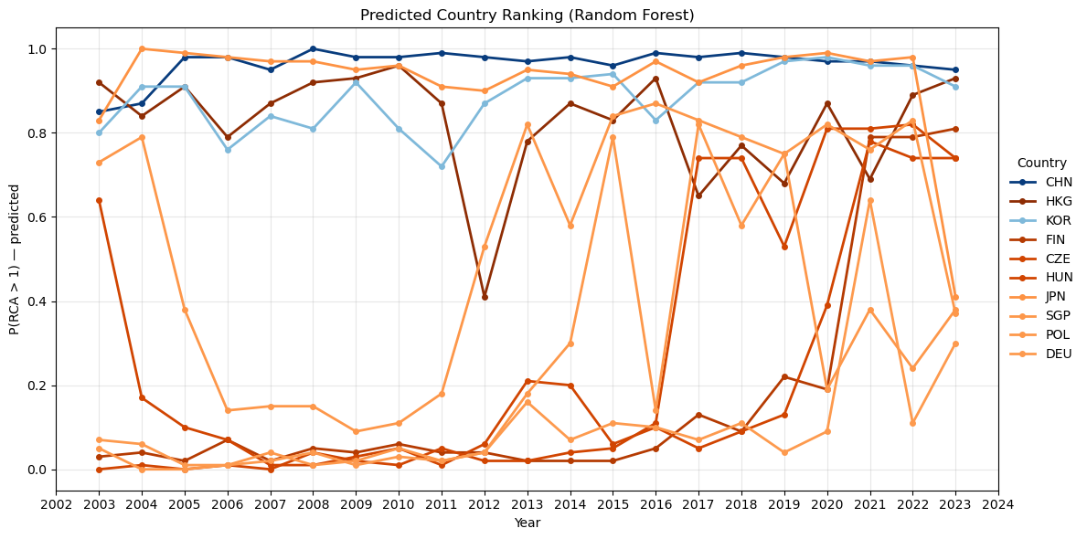
We draw upon SHapley Additive exPlanations (SHAP) values to identify the independent variable that are most important to predict competition. However, the magnitude of SHAP values may vary across models based on the level of class imbalance in the dependent variable, which varies by technology, and subsequent strength of each feature in predicting the dependent variable. We standardize SHAP values to a year-specific z-score to manage this variance and evaluate the importance of features on a comparable scale across clean technologies. After standardizing each SHAP value to a year-specific z-score, we average z-scores across years. We then select independent variables with a value above 0.5, which allows us to retain and consider any such variables with at least moderate importance to the model (Cohen 2013). We provide a list of each feature with a z-score above 0.5 for each technology in Supplementary Information Section Table SI.15-24.
A.4. Model Sensitivity
We evaluate the consistency of our results and sensitivity to randomness in light of our estimation approach and class imbalance in our dependent variables. To do so, we run the model for each technology over 50 different random states. In figures SI.18 - 27,, we plot the corresponding rankings of the top 50 countries to evaluate rank stability.
We find that very highly ranked countries (e.g. those in the top 10) are extremely stable, with countries exhibiting little movement in rankings. Lower rankings are less stable, however. Beyond rankings of 15 and especially 25, each country’s predicted competitiveness becomes much closer to zero. As a result, the absolute differences in predicted competitiveness become smaller, and changes in the random state accordingly create more variation in these countries’ rankings, as illustrated by the greater spread among lower ranked countries. This issue is most pervasive in technologies with highest class imbalance as this ensures that a larger share of total countries have low predicted competitiveness.
Due to the stability of rankings in the top 10-15 countries, we focus on this range for our primary models runs and our discussions of implications for key leaders in each technology. While lower ranked countries do have more noise across random states, our key takeaways for leadership in each technology are therefore not overly sensitive to this variability.

